ROBALO Victor Rouen, 20/01/2026
 22 rue d’Harcourt
76000 Rouen
 : victor.robalo@yahoo.fr
 : 07 68 73 97 74
: Permis B + véhicule Sanofi
Accelerator Data Science

Subject : Application for Data Scientist – R&D Digital Transformation

Dear Hiring Manager,
Having recently completed my three year apprenticeship within Sanofi, I am highly motivated to transition into a permanent role as a Data Scientist. My journey over the last three years has given me a deep understanding of Sanofi’s "Play to Win" strategy and our ambition to become the leading AI powered biopharmaceutical company. I am eager to continue contributing to our mission of chasing the miracles of science to improve patients' lives.
During my time at Sanofi, particularly within the industrial and production environments at Val de Reuil, I have developed a strong expertise in the end to end data lifecycle. I managed data projects focused on transforming raw industrial data into actionable KPIs and high impact Power BI dashboards. This experience taught me how to navigate Sanofi’s complex regulatory environment while delivering pragmatic digital solutions that improve operational efficiency.
More recently, I have shifted my focus toward advanced Data Engineering and Analytics. I have been responsible for defining data strategies, building robust pipelines using dbt and Dataform, and ensuring data quality at scale. My ability to monitor and optimize BigQuery costs demonstrates my commitment to delivering technically excellent yet cost effective AI solutions a mindset that is essential for scaling Digital R&D products.
What excites me about this specific position is the opportunity to apply these skills to New Drug Discovery and Trial Efficiency. I am a firm believer that the intersection of breakthrough science and AI is where we can truly reduce cycle times and deliver medicines faster. Having worked in a cross functional environment at Sanofi, I am comfortable acting as a bridge between complex technical requirements and the strategic needs of our scientists and healthcare partners.
My technical stack : combining Python, SQL, Machine Learning, and Cloud Architecture (GCP) alongside my "Sanofi culture" DNA, allows me to be immediately operational. I am an influencer who is not afraid to challenge the status quo to ensure that our AI models are not just technically robust, but also have a tangible impact on patient outcomes.
I would welcome the opportunity to discuss how my three years of internal experience and my technical evolution can help accelerate Sanofi’s Digital R&D roadmap.
Thank you for your time and for your continued trust in my professional development.
Yours sincerely,
.
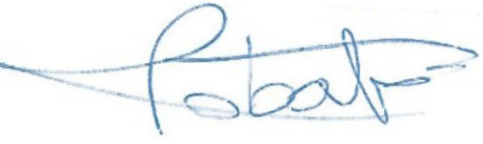

Victor ROBALO

